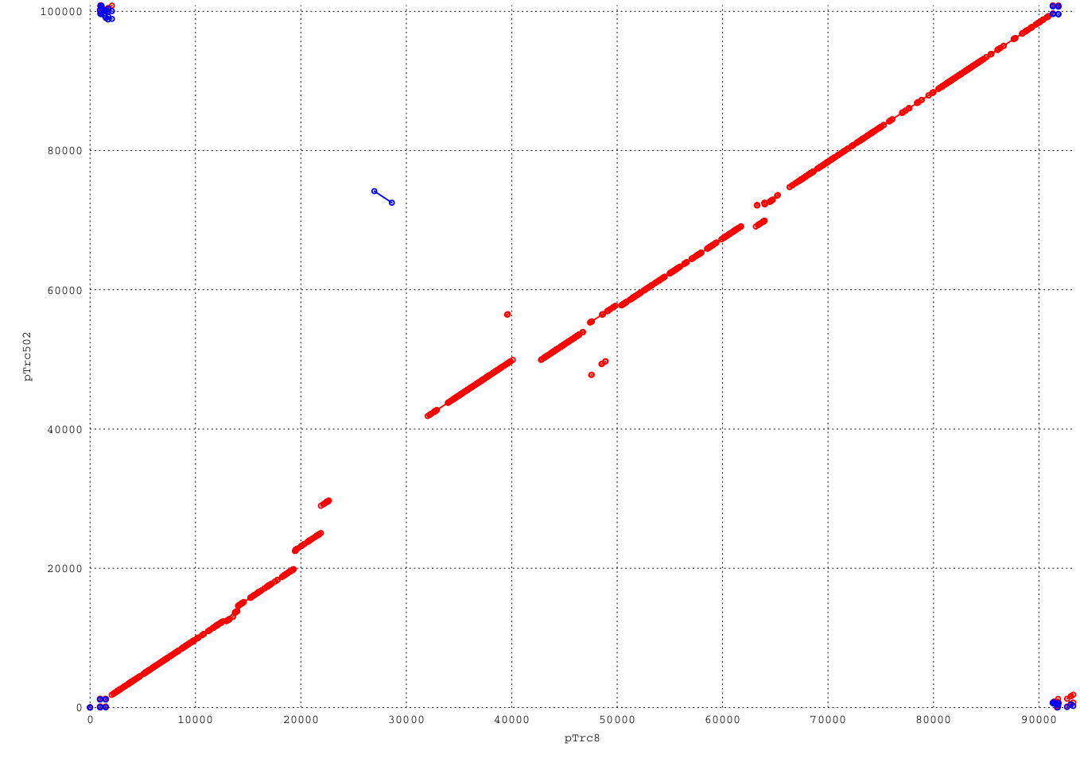

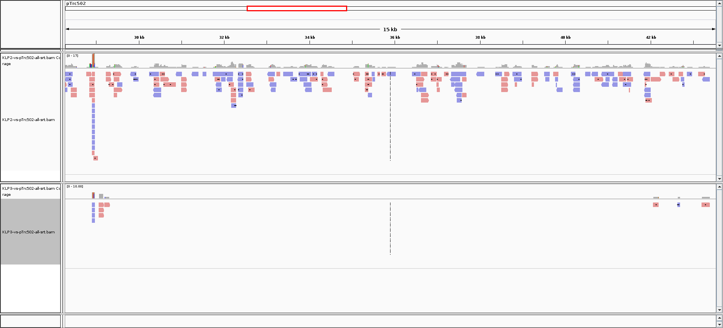

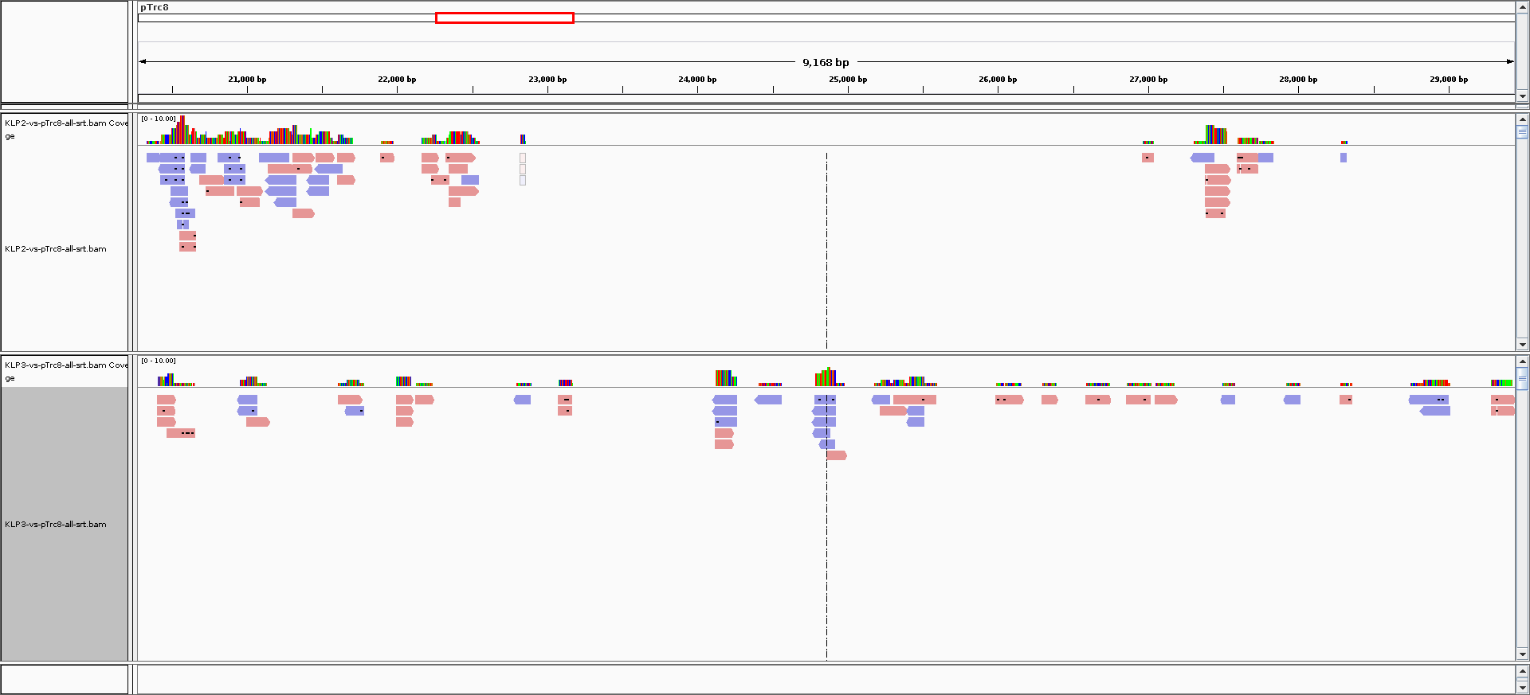

The following samples were sequenced using the Ion Proton:
KLPNC1-ecoli-res (1453369 reads, Mean Read Length: 130 bp)
KLPNC2-Trs502 (1091825 reads, Mean Read Length: 131 bp)
KLPNC3-Trs8 (1434440 reads, Mean Read Length: 133 bp)

All reads were aligned to the provided reference assemblies:
WG5 - the recipient E.coli (4522677 bp)
Trs502 (100886 bp)
Trs8 (93387 bp)
using bwa (version 0.7.16a) with default parameters.

samtools flagstat KLP1-vs-pTrc502-29330-42050.bam
0 + 0 in total (QC-passed reads + QC-failed reads)
0 + 0 duplicates
0 + 0 mapped (-nan%:-nan%)
samtools flagstat KLP2-vs-pTrc502-29330-42050.bam
143 + 0 in total (QC-passed reads + QC-failed reads)
0 + 0 duplicates
143 + 0 mapped (100.00%:-nan%)
samtools flagstat KLP3-vs-pTrc502-29330-42050.bam
0 + 0 in total (QC-passed reads + QC-failed reads)
0 + 0 duplicates
0 + 0 mapped (-nan%:-nan%)

samtools flagstat KLP1-vs-pTrc8-23000-26950.bam
0 + 0 in total (QC-passed reads + QC-failed reads)
0 + 0 duplicates
0 + 0 mapped (-nan%:-nan%)
samtools flagstat KLP2-vs-pTrc8-23000-26950.bam
0 + 0 in total (QC-passed reads + QC-failed reads)
0 + 0 duplicates
0 + 0 mapped (-nan%:-nan%)
samtools flagstat KLP3-vs-pTrc8-23000-26950.bam
23 + 0 in total (QC-passed reads + QC-failed reads)
0 + 0 duplicates
23 + 0 mapped (100.00%:-nan%)

MUMmer3.23

